**Website Design Proposal**

- Driving Quizzes Website

Prepared for:

Manitoba MPI

Created by:

Zhuye Che

**Website Description:**

Manitoba Public Insurance Corporation is the non-profit Crown corporation which administers public auto insurance, motor vehicle registration, and driver licensing in the province of Manitoba. Manitoba MPI requires a design for the website where driving learners can practice and prepare for the knowledge test. The website should provide questions randomly picked from database and offer the correct answers after submission. There are two types of users of the website:

1. General User

* Able to select number of questions to be taken
* Able to view the questions and answers after submission
* Able to leave comment/feedback/suggestion on the website

1. Administrator:

* Able to add new questions to database
* Able to Edit/Delete questions in database
* Able to View/Sort/List all the questions

**Database Structure:**

**Database ERD**

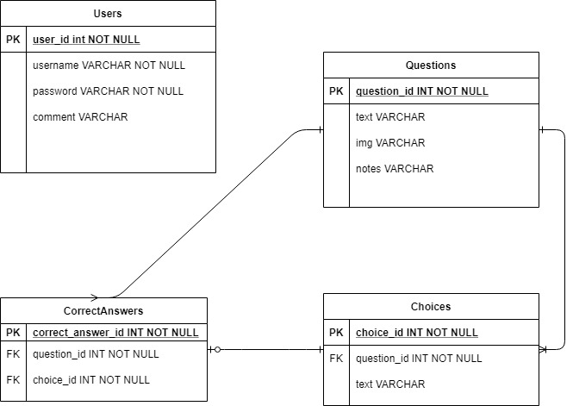

**Table Descriptions:**

*Users* Table will store the username and password to be validated to access the different functions of the website.

*Questions* Table will store the driving test questions and question image link (if it exists)

*Choices* Table will store the choices associated with the related question.

*CorrectAnswers* Table will store the correct answers. Each correct answer associated to a question and a choice.

Note:

*UserRecords* Table may be added as development to record the user best score and attempts. (Not on the ERD yet)

**Table Associations:**

One question will have one to many choices, and one choice will associate with one question.

One question will have one to many correct answers, and one correct answer will associate with one question and one choice.

One Choice will associate with zero or one correct answer.